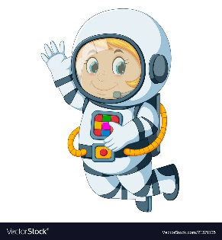
Astronaut Spellings
Week 2 18th January
Special Focus
whether
weather
scene
seen
week
weak
ball
bawl
plain
plane

